Theme: Startup Office IT Setup
Section A: Scenario-Based Concept Application
1. Selection process for CPU, RAM, and storage specifications to ensure compatibility and avoid performance bottlenecks
1. CPU (Processor)
The CPU should handle many tasks at the same time because developers often use:
- Coding software (IDE)
- Web browsers
- Compilers
- Virtual machines
- Video meeting apps
Recommended:
- Choose a processor with 6–8 cores
- Make sure the CPU works with the motherboard

2. RAM (Memory)
RAM helps the computer run many applications smoothly.
Recommended:
- 16 GB RAM → enough for normal development work
- 32 GB RAM → better if using virtual machines, containers, or doing heavy multitasking
Important:
- RAM type (DDR4 or DDR5) should match the motherboard

3. Storage
Storage affects how fast the computer starts and opens files.
Recommended:
- Use SSD instead of HDD because SSD is faster
- NVMe SSD is faster than a normal SATA SSD
Suggested setup:
- 512 GB–1 TB SSD → for Windows and applications
- Extra storage → for project files and backups

4. Avoid Performance Problems
All parts should work in balance.
Examples:
- Fast CPU + low RAM → system becomes slow
- Large RAM + slow storage → apps open slowly
Best balanced setup:
- CPU: 6–8 cores
- RAM: 32 GB
- Storage: 1 TB NVMe SSD
This setup gives smooth performance for coding, multitasking, and video meetings.

2. How resource allocation and hardware bottlenecks affect performance after deploying antivirus software
Resource-intensive applications such as antivirus software continuously consume system resources.
Impact of System Resource Allocation
- Antivirus programs use CPU resources for scanning files.
- They consume RAM to maintain active background processes.
- Disk usage increases during real-time file monitoring.
Performance Degradation Process
- Antivirus starts background scanning.
- CPU cycles are shared between user applications and antivirus tasks.
- Memory usage increases, reducing available RAM.
- Disk access becomes slower because of constant file checking.
- Applications become less responsive.
Hardware Bottlenecks
- Limited RAM causes frequent swapping to disk memory.
- Slow HDD storage increases waiting time during scans.
- Low-core CPUs struggle with multiple tasks simultaneously.
Result
Users may experience:
- Slow system response
- Lag during video meetings
- Delayed software compilation
- Longer application loading times

3. Systematic troubleshooting process for peripheral hardware failures caused by driver incompatibility or operating system conflicts
When a peripheral device works on one workstation but fails on another, a systematic approach should be followed:
Step 1: Identify the problem
- Observe symptoms such as intermittent disconnection, non-detection, or error messages.
Step 2: Check physical connections
- Verify cables, ports, and power supply.
- Test the device on another system.
Step 3: Verify driver status
- Open Device Manager.
- Look for warning symbols indicating driver issues.
Step 4: Update or reinstall drivers
- Install the latest compatible drivers.
- Remove corrupted drivers and reinstall them.
Step 5: Check operating system compatibility
- Confirm whether the peripheral supports the installed OS version.
Step 6: Examine software conflicts
- Identify recently installed software that may interfere with device operation.
Step 7: Test functionality
- Restart the system and verify whether the issue is resolved.
Outcome
This process helps isolate whether the problem originates from hardware failure, drivers, or operating system conflicts.

4. Role of UPS systems and surge protection in preventing file system corruption and ensuring data integrity
A Uninterruptible Power Supply (UPS) provides temporary backup power during power interruptions, while surge protectors defend against voltage spikes.
Role of UPS
- Supplies immediate power during outages.
- Allows users to save work and shut down systems safely.
- Prevents abrupt system shutdowns.
How UPS prevents file system corruption
- Sudden shutdowns may interrupt file-writing operations.
- Incomplete writing can damage file structures.
- UPS provides enough time for the operating system to complete ongoing processes.
Role of Surge Protection
- Blocks excessive voltage from reaching hardware.
- Protects storage devices and motherboards from electrical damage.
Ensuring Data Integrity
Benefits include:
- Reduced risk of corrupted files
- Protection of databases and project data
- Prevention of hardware damage
- Improved system reliability and business continuity
Conclusion:
Using UPS systems with surge protection helps maintain stable operations and protects startup data from unexpected power-related failures.

Section B: Practical Application
Tools: PC Tool Kit, Cisco Packet Tracer, Windows/Linux ISO, VirtualBox.
● Task 1: Physically assemble a workstation and document the component installation sequence.
sObjective: Assemble a startup workstation and ensure successful hardware installation.
Component Installation Sequence
- Prepare workspace
  - Wear anti-static wrist strap
  - Arrange required tools and components
- Install CPU
  - Open motherboard CPU socket
  - Align processor indicator marks
  - Carefully place CPU into socket
  - Lock the socket
- Apply thermal paste
  - Apply a small amount of thermal paste on CPU surface
- Install CPU cooler
  - Mount heat sink/fan
  - Connect CPU fan cable to motherboard
- Install RAM
  - Open RAM slot clips
  - Align RAM notch correctly
  - Press firmly until clips lock
- Install motherboard into case
  - Place I/O shield
  - Mount motherboard using screws
- Install storage device
  - Install SSD/HDD in drive bay
  - Connect SATA and power cables
- Install power supply unit (PSU)
  - Secure PSU inside cabinet
  - Connect power cables
- Connect front panel cables
  - Power switch
  - Reset switch
  - USB connectors
  - Audio connectors
- Install graphics card (if required)
- Insert into PCIe slot
- Connect additional power cables
- Cable management
- Organize and secure cables
- Power on system
- Verify system starts successfully
Expected Result:
System completes POST (Power-On Self-Test) without hardware errors.

● Task 2: Troubleshoot and resolve a RAM mismatch error within the BIOS/UEFI settings.
Problem: BIOS reports RAM mismatch or incorrect memory detection.
Troubleshooting Procedure
Step 1: Verify RAM installation
- Turn off computer
- Remove and reinsert RAM modules properly
Step 2: Check RAM compatibility
- Verify:
  - DDR type (DDR4/DDR5)
  - Frequency
  - Capacity
  - Motherboard support
Step 3: Enter BIOS/UEFI
- Press F2, Delete, or manufacturer-specific key during startup
Step 4: Inspect memory settings
- Check detected RAM capacity
- Review memory frequency settings
Step 5: Configure memory
- Enable XMP profile if supported
- Set memory frequency to compatible speed
- Disable overclocking if unstable
Step 6: Save and restart
- Save settings
- Reboot system
Expected Result:
BIOS correctly recognizes installed RAM and no mismatch errors appear.

● Task 3: Build a LAN topology in Packet Tracer for 5 systems and 1 printer using a Class C subnet.
Network Design
ANS:
Here's a simple step-by-step practical for building a LAN topology in Cisco Packet Tracer with 5 PCs and 1 Printer using a Class C subnet.
Aim
To create a LAN topology with 5 computers and 1 printer using a Class C IP network.
Network Details
- Network Address: 192.168.1.0/24
- Subnet Mask: 255.255.255.0
IP Address Table
Device | IP Address | Subnet Mask
PC0 | 192.168.1.1 | 255.255.255.0
PC1 | 192.168.1.2 | 255.255.255.0
PC2 | 192.168.1.3 | 255.255.255.0
PC3 | 192.168.1.4 | 255.255.255.0
PC4 | 192.168.1.5 | 255.255.255.0
Printer | 192.168.1.10 | 255.255.255.0

Step 1: Open Packet Tracer
Launch Cisco Packet Tracer.

Step 2: Add Devices
From the bottom-left menu:
- Select End Devices.
- Drag and drop:
  - 5 PCs (PC0–PC4)
  - 1 Printer
- Select Switches.
- Drag one 2960 Switch to the workspace.
Your topology should have:
- 1 Switch
- 5 PCs
- 1 Printer

Step 3: Connect Devices
- Click Connections (lightning bolt icon).
- Select Copper Straight-Through Cable.
- Connect:
Device | Switch Port
PC0 | FastEthernet0/1
PC1 | FastEthernet0/2
PC2 | FastEthernet0/3
PC3 | FastEthernet0/4
PC4 | FastEthernet0/5
Printer | FastEthernet0/6
Wait until the link lights turn green.

Step 4: Configure IP Addresses
PC0
Desktop → IP Configuration
- IP Address: 192.168.1.1
- Subnet Mask: 255.255.255.0
PC1
- IP Address: 192.168.1.2
- Subnet Mask: 255.255.255.0
PC2
- IP Address: 192.168.1.3
- Subnet Mask: 255.255.255.0
PC3
- IP Address: 192.168.1.4
- Subnet Mask: 255.255.255.0
PC4
- IP Address: 192.168.1.5
- Subnet Mask: 255.255.255.0
Printer
Config → FastEthernet
- IP Address: 192.168.1.10
- Subnet Mask: 255.255.255.0

Step 5: Verify Connectivity
From PC0
Desktop → Command Prompt
Type:
ping 192.168.1.2
Expected result:
Reply from 192.168.1.2
Now test:
ping 192.168.1.3
ping 192.168.1.4
ping 192.168.1.5
ping 192.168.1.10
All pings should be successful.
Result
A LAN network containing 5 PCs and 1 Printer was successfully created using the Class C network 192.168.1.0/24, and connectivity was verified using the ping command. ✅

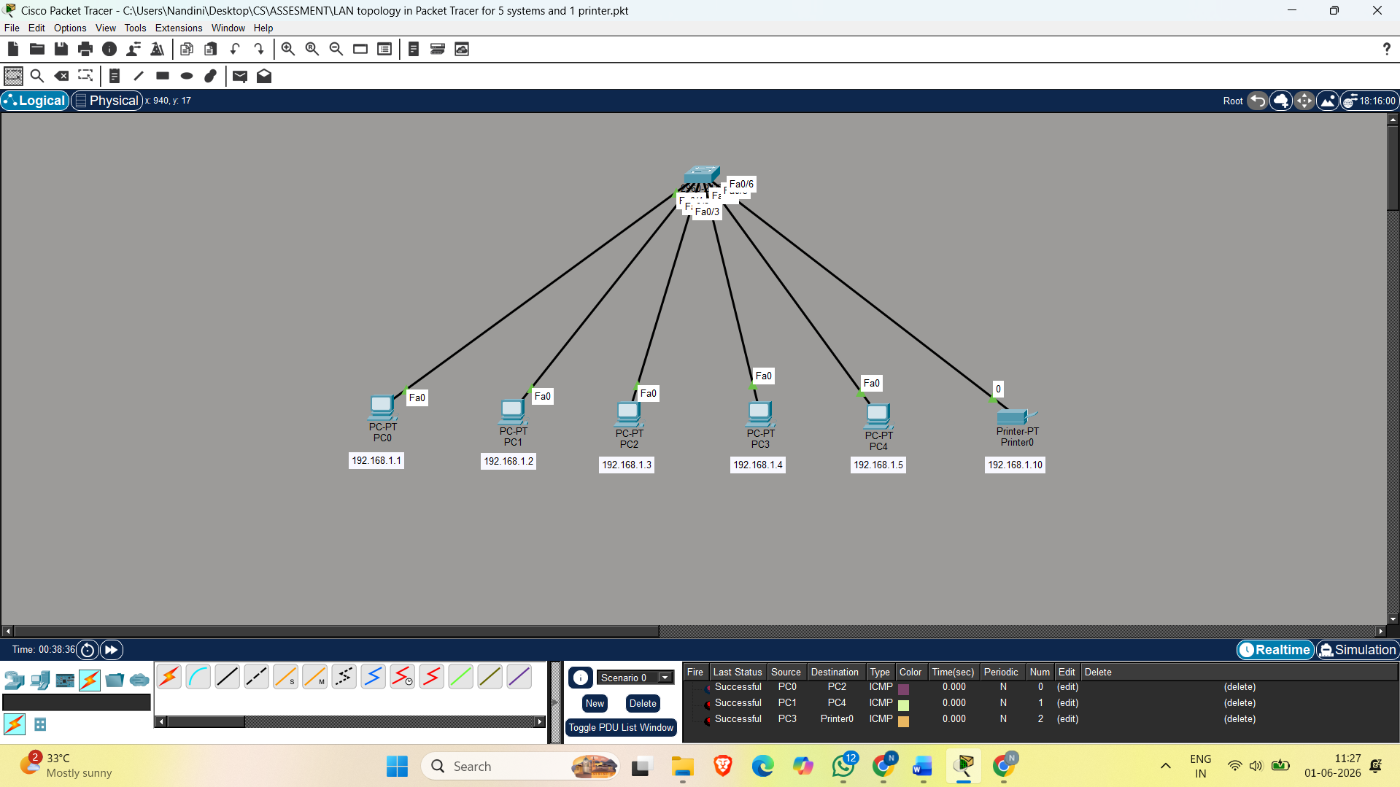

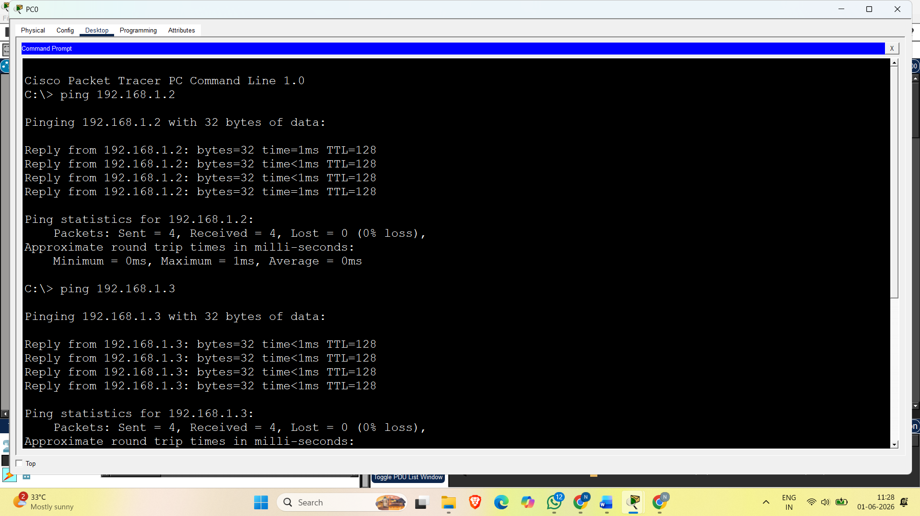

● Task 4: Perform a clean OS installation with manual disk partitioning and startup optimization.
Installation Steps
Step 1: Boot from ISO
- Mount Windows/Linux ISO in VirtualBox
- Start virtual machine
Step 2: Begin installation
- Select language and keyboard layout
Step 3: Manual disk partitioning
Example:
Partition | Size | Purpose
C: | 100 GB | Operating System
D: | Remaining space | Data storage
For Linux:
Partition | Size
Root (/) | 50 GB
Swap | 4–8 GB
Home (/home) | Remaining
Step 4: Install operating system
- Complete installation process
- Create user account
Step 5: Install drivers
- Install motherboard and device drivers
Step 6: Startup optimization
- Disable unnecessary startup applications
- Enable automatic updates
- Configure antivirus settings
Expected Result:
Operating system boots normally without startup errors.

Success Criteria: System passes POST, all IPs are reachable via Ping, and the OS boots without errors.
Success Criteria Verification
Criteria Status
POST completed successfully ✓
RAM recognized correctly ✓
All systems reachable using Ping ✓
Printer connected successfully ✓
OS boots without errors ✓

Final Outcome: The startup office workstation and network setup are successfully configured and operational.

Section C: Integrated Case Study
Scenario: Nexus Innovations – Random Restarts During Heavy Workloads

1. Three hardware components most likely to cause random reboots under load
The three most probable hardware components are:
a) CPU and CPU Cooling System
- During rendering tasks, CPU utilization becomes very high.
- Poor cooling can increase temperature beyond safe operating limits.
- Thermal protection mechanisms may automatically restart the system.
b) Power Supply Unit (PSU)
- Rendering workstations require high power for CPU and GPU operations.
- If the PSU cannot supply stable voltage under peak load, sudden reboots can occur.
c) Graphics Processing Unit (GPU)
- Rendering applications place heavy load on the GPU.
- Overheating or unstable power delivery to the GPU may trigger system restarts.

2. Why the systems pass POST in the morning but fail in the afternoon
Morning Conditions
- Systems start in a cooler environment.
- Internal components are at lower temperatures.
- POST only performs basic hardware checks and does not place sustained stress on components.
Afternoon Conditions
- Poorly ventilated desk cabinets trap heat.
- Continuous workload gradually increases temperatures.
- Rendering tasks heavily utilize CPU and GPU resources.
- Heat accumulation causes thermal throttling or automatic shutdown/restart mechanisms.
Reason:
POST verifies whether hardware is present and functioning at startup, but it does not simulate prolonged heavy workloads.

3. Using a stress-test tool to confirm a thermal or power issue
A stress-testing process can isolate the problem.
Procedure
- Install monitoring software:
  - CPU temperature monitor
  - GPU monitoring tool
  - Voltage monitoring utility
- Run stress tests:
  - CPU stress test
  - GPU stress test
  - Combined system load test
- Observe:
  - CPU temperature rise
  - GPU temperature rise
  - Voltage fluctuations
  - Fan speeds
  - Time until reboot
Expected Findings
Thermal issue
- Temperature rises above safe limits (for example >90–100°C depending on hardware)
- System restarts when temperature peaks
Power issue
- Temperatures remain acceptable
- Voltage levels fluctuate or drop under load
- Restart occurs during peak power demand

4. Three specific steps to remediate frequent system restarts
Step 1: Improve ventilation
- Remove systems from enclosed desk cabinets
- Maintain airflow around workstation cases
- Ensure intake and exhaust vents remain unobstructed
Step 2: Improve cooling system
- Clean dust from fans and heat sinks
- Replace thermal paste if degraded
- Add or upgrade cabinet/case cooling fans
Step 3: Perform hardware diagnostics
- Test PSU output stability
- Check CPU and GPU temperatures under load
- Update BIOS and hardware drivers if needed

5. Technical justification for whether a PSU upgrade is necessary
A PSU upgrade may be necessary if:
- Existing PSU wattage is lower than total system requirements
- Voltage drops occur during heavy rendering
- PSU efficiency is poor
- Hardware upgrades increased power demand
A PSU upgrade might not be necessary if:
- Stress testing shows stable voltage output
- Power consumption remains within PSU capacity
- Thermal buildup is identified as the main cause
Technical Justification:
Random restarts under heavy load often resemble PSU failure symptoms, but the presence of poorly ventilated cabinets strongly suggests heat accumulation as the primary issue. A PSU upgrade should only be recommended after power testing confirms insufficient or unstable power delivery.
Conclusion:
The most likely root cause is overheating due to restricted airflow, while PSU limitations should be validated through stress testing before replacement.

